|  |  |
| --- | --- |
| **Test Case:** *Pesquisa Buscape*  **Expected Result:** *Result OK*  **Status:** *Failed* | **Date :** *24/08/2020*  **Hour:** *15:20* |

**1. OBJECTIVE**

This document aims to provide proof of the tests run for application validation.

2. EVIDENCE OF TEST STEPS

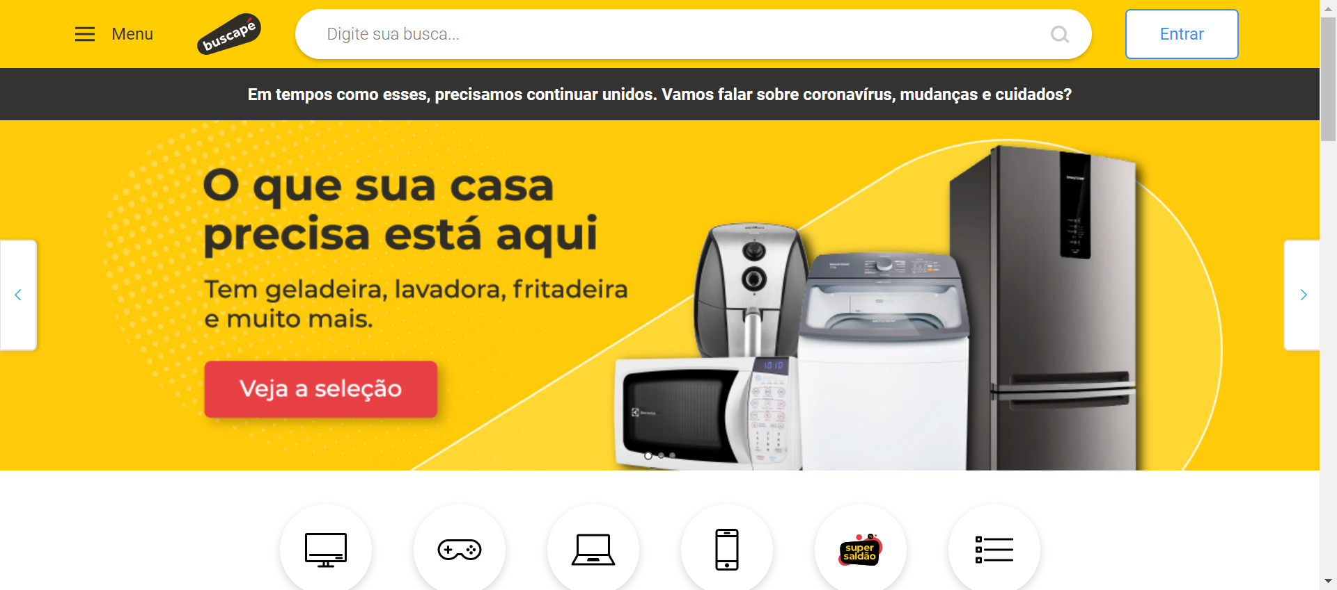

|  |  |
| --- | --- |
| Action: Navigate | Action time: 00:00:26 |
| Resultado expect: The page was successfully loaded | Resultado obtained: The page was successfully loaded |



|  |  |
| --- | --- |
| Action: SendKeys | Action time: 00:00:10 |
| Resultado expect: The field was successfully filled | Resultado obtained: The field is not successfully filled |